**5. Prototype Design Pattern**

prototype design pattern which is also called clone design pattern in c++ programming language.

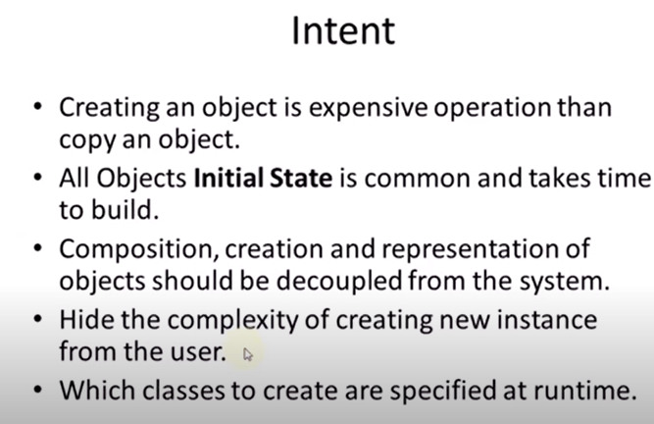

**Example scenario, when to use Prototype Design Pattern:**  
For example, constructor is taking hell lot of time creating an object and the same object is being used at many places and many times.

**Bullet Example:**

Different bullets takes some standard time and this part can be saved in a registry and just load this before firing a bullet.

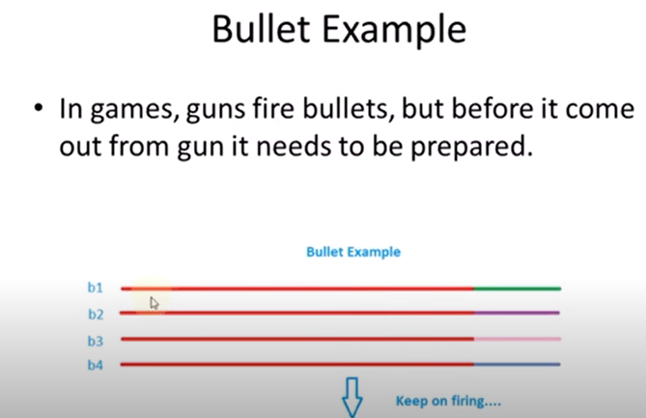

**UML Diagram:**  
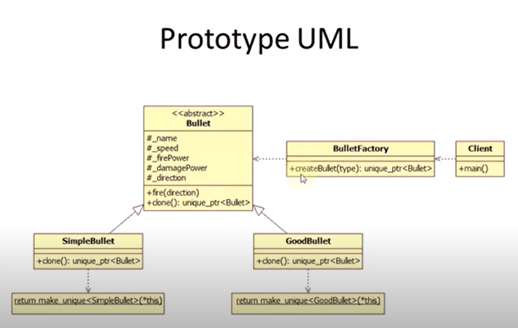

**More Info at:**https://refactoring.guru/design-patterns/prototype